Project Name:

University specialization Project

Group (1)

ICS202: lab

Report Done By

Rehab Mohammed \ ID: 201712532 \ COE

Asma Murdi \ ID: 201712471 \ SWE

Noha Rashed \ ID: 201710328 \ COE

Mariam Alhamidi \ ID: 201611596 \ CS

Afrah Hasaan \ ID: 201716906 \ SWE

Instructor Name: Hula Alkhassawneh

1. **Introduction**

Now, upon the completion of each student from the first preparatory year, he must choose his university specialization that he will study. Create a code to display some of the university's specializations.

The program explains to each student what specialization he wants to choose, as he applied his coding as he learned during the lectures and used the program to apply the code.

1. **Abstract**

In this code, I used the stack for linear data, we added several elements from the top of the stack, and we used the utility library: import java.util. *;. The method used to add items from the top of the stack is known as payment, as I added some university majors and allowed the student to choose the major number he wanted.

1. **Code**

package ADTs;

import ADTs.*;

import java.util.*;

public class Java3Project {

public static void main (String [] args){

Scanner S = new Scanner (System.in);

StackAsArray stack = new StackAsArray(10);

System.out.print("Enter your name :");

String name =S.next();

System.out.print("\nEnter your ID Number:");

String ID =S.next();

System.out.println("");

stack.push (new String("* 1. computer engineering *"));

stack.push (new String("* 2. Software engineering *"));

stack.push (new String("* 3. Accounting *"));

stack.push (new String("* 4. Kindergarten *"));

stack.push (new String("* 5. English Literature *"));

System.out.println("The removed last specialization is: " +stack.pop());

System.out.println("The top University specializatio is: " +stack.getTop());

System.out.println("Please Write the number of University specialization :");

Enumeration i= stack.getEnumeration();

while (i.hasMoreElements()) {

Object o = i.nextElement();

System.out.println(o ); }

int num =S.nextInt();

switch (num){

case 5:

System.out.println(" Your University specialization is computer engineering");

break;

case 4:

System.out.println(" Your University specialization is Software engineering");

break;

case 3:

System.out.println(" Your University specialization is Accounting ");

break;

case 2: System.out.println("Your University specialization is Kindergarten ");

break;

case 1: System.out.println("Your University specialization is English Literature");

break;

default:

System.out.println("Please Select from (1 to 5)");

break;}

System.out.println("Thank you");

}

1. **Result**

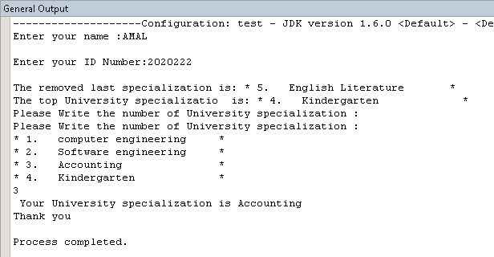

1. **Consultation**

You may know that the code for meds can not be added to any element except from the top, and it depends on only one of the controls, and there is no other. This simple code displays some of the specialties and allows the user to choose the specialty through the keyboard.